

11 Physics

Heating and Cooling
KINETIC THEORY OF MATTER

Any understanding of heat is based upon an understanding of the structure and nature of matter.

The Kinetic Theory makes the following basic assumptions.

• All matter is made up of extremely small particles.
• All particles are in constant random motion.
• Particles collide with neighbouring particles in elastic collisions.
(i.e. no loss of energy)
• A mutual attractive force exists between particles.

Definitions

Heat: the flow of energy from one object to another because of a difference in temperature.

Internal Energy: the sum of the internal kinetic and potential energies of the particles
making up a body.

Temperature: a measure of the average kinetic energy of the particles in a body.

The kinetic energy (E_{k}) of the particles is due to all their movements - translational (movement in straight lines), rotational and vibrational.

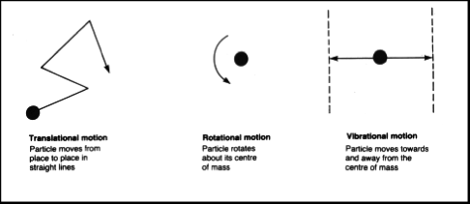

The potential energy (E_{p}) of the particles is due to the attraction between them, this being both gravitational and electromagnetic. (The gravitational forces are negligible.)

The further apart the particles, the greater the E_{p}.

e.g. Gas molecules have more E_{p} than those in a liquid at the same temperature.

Heating a body can cause an increase in the E_{k} of the particles and this will cause them to move further apart. Thus their E_{p} increases as well.

States Of Matter

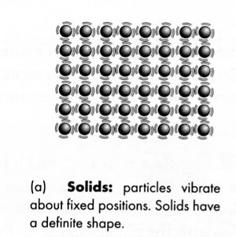
Solid

• Particles are in constant motion about fixed positions.
• Has a fixed shape and volume due to strong bonds
between particles.
• Incompressible.

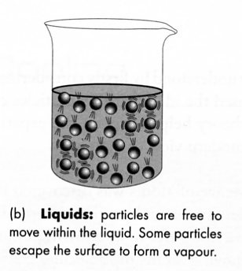

Liquid

• Forces between particles are weaker than in a solid.
• Particles are able to move past one another.
• Takes the shape of the lowest level in the container -
shape not fixed.
• Fixed volume.
• Virtually incompressible.

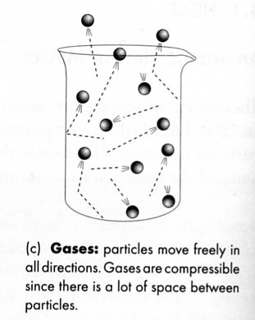
Gas

• Virtually no forces exist between particles so they move
independently to fill the container.
• No fixed shape or volume.
• Compressible.

TEMPERATURE SCALES

There is a clear distinction between heat and temperature.

Heat is the energy transferred from a hot body to a cooler body at a different temperature.

Temperature is a measure of the average E_{k} of the particles in a body.

A thermometer is used to measure the temperature of a body. The scale chosen could be Fahrenheit, Celsius or Kelvin.

The Fahrenheit and Celsius scales were based on two reference points - lowest temperature for an ice/salt mix and the human body temperature for Fahrenheit; melting and boiling points of water for Celsius.

The Kelvin scale has one fixed point - the lowest temperature possible - with no negative numbers. This is an absolute scale.

Absolute Zero: the temperature where all particle motion in a gas ceases and no pressure is
exerted and no volume exists.

This temperature is calculated theoretically by observing the pressure-temperature relationship or volume-temperature relationship for a gas.

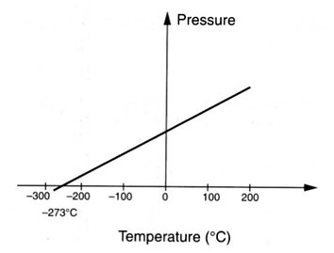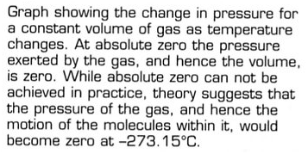

∴ 0.00 K = -273.15 °C

For the purpose of converting °C to K, add 273 to the temperature in °C.

e.g. -134 °C = 273 - 134 = 139 K

Measuring Temperature By Thermal Expansion

Thermometers rely on the expansion of liquids.

e.g. Mercury in laboratory thermometers for -10°C 120 °C.

Alcohol in thermometers for temperatures well below 0 °C.

Thermostats rely on a bi-metallic strip - two different metals joined together. One expands faster than the other and causes the strip to bend. This can be used to turn electric circuits off or on depending on the temperature.

e.g. Temperature control in refrigerators and ovens.

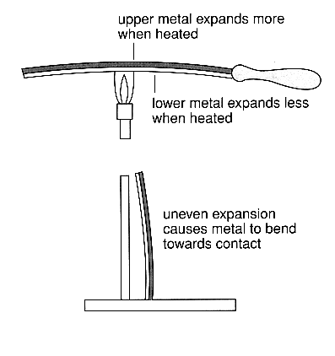

Bi-metallic strips are being replaced with semi-conductors called thermistors that are based on a change of resistance with a change in temperature.

Note

Water is not a useful liquid to use in a thermometer. Whereas most substances contract and shrink in volume with a decrease in temperature, water (silicon, germanium, sterling silver alloys, lead-tin-antimony alloys) expand at a certain temperature.

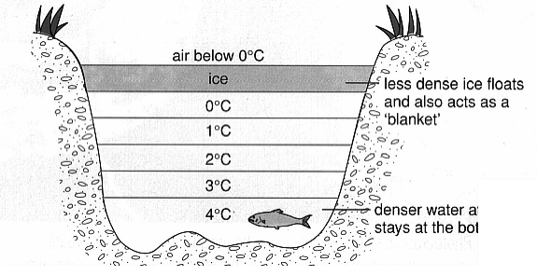
This is known as the anomalous behaviour of water.

At 4 °C water has a density of exactly 1.00 gmL⁻¹. From 4 °C to 0 °C, the water expands as it freezes, causing its density to decrease. Thus ice floats on water.

If this didn't happen, all lakes and rivers would freeze from the bottom up, killing all life!

Below 0 °C, the ice will start to contract again.
Water temperatures in a frozen pond. The unusual expansion of water ensures that large bodies of water rarely freeze to the very bottom.
SPECIFIC HEAT CAPACITY

Simple observations such as those below suggest a relationship between the mass, the type of material and amount of energy and the temperature change caused when objects are heated.

• A small amount of water in a kettle will experience a greater change in
temperature when heated than a large volume.
(Smaller mass greater temperature change.)

• Metal objects left in the sun get hotter much faster than the same mass of water.
(Different materials store different amounts of heat.)

• Larger heaters warm rooms faster than smaller ones.
(The greater the amount of energy supplied, the greater the temperature change.)

From this it can be inferred that the capacity of a given material to absorb energy as it changes temperature is dependent on its mass, type of material and the size of the temperature change. This is called the material's heat capacity.

Some materials are more difficult to heat up than others because they have a greater heat capacity. Materials with large heat capacities can absorb and store more internal energy and when cooled, cool more slowly.

In order to compare the heat capacity of different materials and masses for a fixed temperature change, a specific mass is adopted and specific heat capacity is defined.

Specific Heat Capacity: the amount of energy required to change the temperature of one
kilogram of a material by 1.00 °C or 1.00 K.

i.e.
This equation is generally written as:

Q = m c ΔT

where Q = the heat energy transferred to the material (J)
m = the mass of material (kg)
c = specific heat of the material (Jkg⁻¹K⁻¹)
ΔT = the temperature change (°C or K)

Water has a relatively high specific heat capacity, needing 4.18 x 10³ J of energy to raise the temperature of 1.00 kg by 1.00°C. This makes water an ideal substance to act as a coolant or for heat storage.

Example 1

A solar hot water tank made of 1.10 x 10² kg of steel contains 2.50 x 10² L of water initially at
25.0 °C. How much energy is required to raise the temperature to 60.0 °C?

Since the steel and the water are in contact, it is assumed that they are both at thermal equilibrium.

i.e. They are both at the same temperature and no heat transfers between them.

Q = m_{steel}c_{steel}Δt + m_{w}c_{w}Δt
= (1.10 x 10²)(4.40 x 10²)(35.0) + (2.50 x 10²)(4.18 x 10³)(35.0)
= 3.827 x 10⁷ J

∴ Heat energy required = 3.83 x 10⁷ J

Example 2

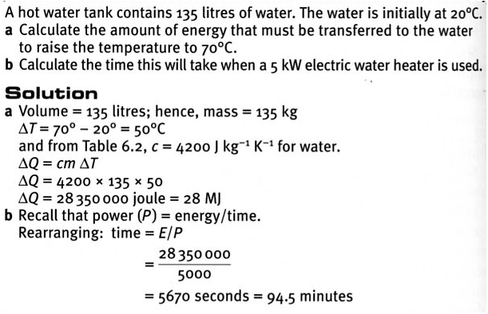

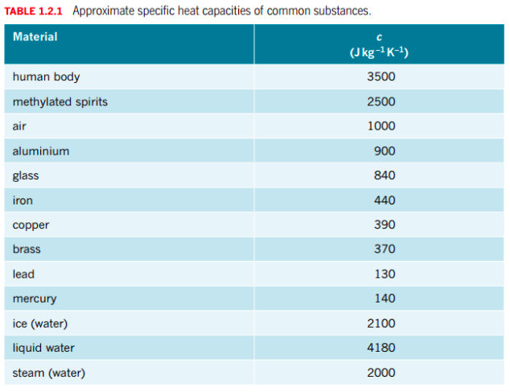
Water - A Special Case

Water has the highest specific heat of all common materials. This means it has a great capacity to hold heat and therefore makes a useful coolant.

e.g. Car radiators, evaporative air conditioners, etc.

Water will heat up slowly and cool down slowly when compared with materials of lower specific heats.

The oceans contain a huge amount of heat and it is this heat that drives the climates of the world. The land heats and cools much more quickly than the ocean and this generates the breezes in a local area.

e.g. A sea breeze occurs when the land is hotter than the ocean.

Hot air becomes less dense and rises.
Air cools and moves out to sea.
Air becomes more dense and moves down to sea level.
Cool air moves in to replace the warm air.
Temperature of the land is higher than the ocean.
SEA
LAND

During the winter when Perth has very cold nights of 3-4 °C, Rottnest is always about 16 °C. This is due to it being surrounded by water, which keeps the air warm.

Thermal Equilibrium

As mentioned in the example above, objects of different temperatures will transfer heat energy between themselves until they reach a common final temperature.

i.e. Heat energy moves from the hotter material to the cooler one.

This does not mean that both materials have the same amount of internal energy - that is determined by the respective specific heats and mass of each material.
LATENT HEAT

The heating and cooling curves of all materials shows plateaux occurring at temperatures where a change of phase is taking place.

i.e. No temperature increase is taking place, implying that the average E_{k} of the particles is not changing.

What is the heat energy doing?

It is changing the E_{p} of the particles by moving them further apart or closer together, depending on the process taking place.

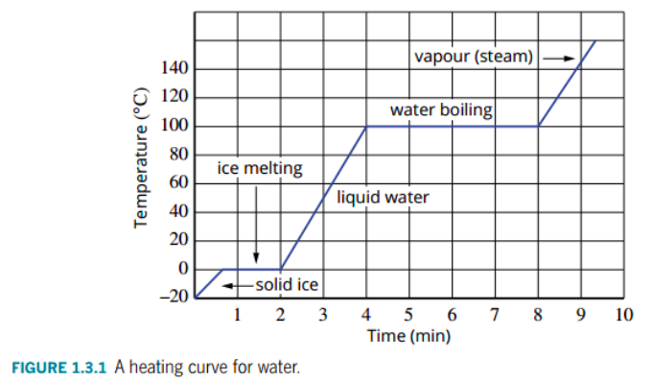
The heating curve above is for water. It shows a plateau at the melting and boiling points. The plateau at the boiling point is much larger than that at the melting point as it takes much more energy to overcome the attractive forces between water molecules to have them move independently .

The heat energy involved in a phase change is called the latent heat.

Latent Heat Of Fusion (L_{f}): heat energy required to change 1.00 kg of a material from a
solid to a liquid at its melting point.

Latent Heat Of Vaporisation (L_{v}): heat energy required to change 1.00 kg of a material from
a liquid to a gas at its boiling point.

(These definitions also apply to the phase changes: liquid solid and gas liquid.)

The latent heat involved in a phase change is given by :

where Q = heat required for the phase change (J)
m = mass of the substance (kg)
L = latent heat for the phase change (Jkg⁻¹)
Problem Solving

Most problems involving heat energy consider both latent heat and specific heat effects. It is a good idea to use a simple diagram to show the steps involved.

Basic rule - a temperature change involves specific heat; a phase change involves
latent heat.

Example

Calculate the heat energy required to change 0.500 kg of water at 25.0 °C to steam at 1.00 x 10² °C.
Water at 25.0 °C 100 °C.
Water changes phase at 100 °C.
STEAM

Q = m_{w}c_{w}Δt + mL_{v}
= (0.500)(4.18 x 10³)(75.0) + (0.500)(2.25 x 10⁶)
= 1.282 x 10⁶ J

∴ Heat required = 1.28 x 10⁶ J

METHOD OF MIXTURES

A convenient way to solve problems involving a mixture of substances at different temperatures and phases is to recognise that the resulting mixture will arrive at a final temperature.

i.e. They reach thermal equilibrium.

Assuming no heat is lost to the surroundings, the heat lost by the hotter substances will be gained by the cooler substances.

i.e. Q_{lost} = Q_{gained}

Example 1

A 25.0 g block of ice is added to a 0.100 kg glass containing 0.250 kg of water at 20.0 °C. Calculate the final temperature of the mixture.
(c_{glass} = 8.40 x 10² Jkg⁻¹K⁻¹)

T = 20 °C T_{f}
ice melts water at 0 °C water at T_{f}
water

Q_{lost} = Q_{gained}
⇒ m_{w}c_{w}Δt + m_{g}c_{g}Δt = m_{i}L_{f} + m_{i}c_{w}Δt
⇒ (0.250)(4.18 x 10³)(20.0 - T_{f}) + (0.100)(8.40x10²)(20.0 - T_{f}) = (0.025)(3.34x10⁵) +
(0.025)(4.18 x 10³)(T_{f} - 0)
⇒ T_{f} = 11.54 °C

∴ Final temperature = 11.5 °C

Example 2
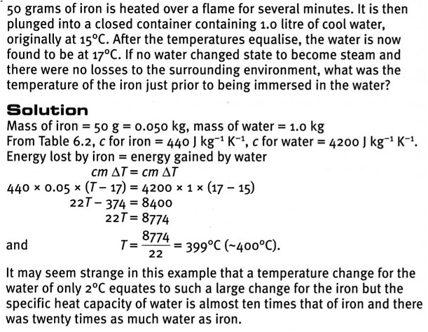

EVAPORATION

Evaporation occurs from the surface of a liquid at all temperatures below the boiling point.

Particles with enough E_{k} to overcome the attractive forces between the particles in the liquid leave the surface and enter a vapour state just above the surface.

The average E_{k} of the particles remaining in the liquid is lower and hence the temperature drops. This is why evaporation has a cooling effect.

Particles with high E_{k} leave the surface.
Average E_{k} drops and hence temperature is lower.

Examples

1. Human skin

The body sweats, putting a film of water onto the surface of the skin. The water absorbs heat from the skin, causing the number of particles with enough E_{k} to overcome the attractive forces to rise. Hence the water evaporates and reduces the temperature of the skin.

2. Swimming

On leaving the water, the layer against the skin evaporates and removes heat from the body.

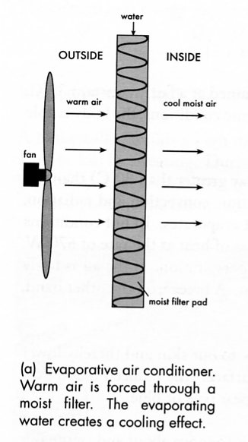
3. Evaporative air conditioning, Coolgardie safes from the early pioneering days, the canvas water bags carried on vehicles in the outback - they all rely on water evaporating to remove heat.
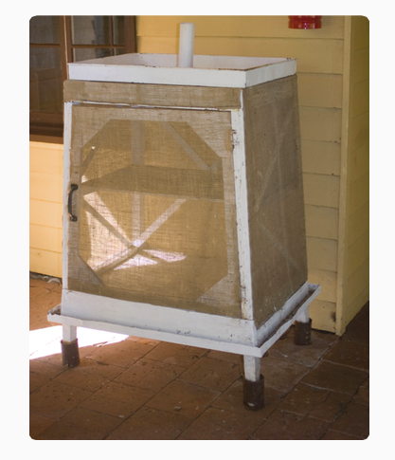

RATE OF EVAPORATION

The rate of evaporation is affected by the following factors.

Temperature

• The greater the temperature of the liquid, the faster it evaporates.

At higher temperatures, more particles have enough E_{k} to leave the surface.

Humidity

• The higher the humidity, the lower the rate of evaporation.

In a closed container particles are able to leave and return to the surface of the liquid. Eventually an equilibrium is reached where the number of particles leaving equals the number returning. The air is saturated and no more particles may enter it.

In high humidity, the air is nearly saturated so very few particles can leave the liquid to enter the atmosphere. Hence the temperature of the liquid changes very little.

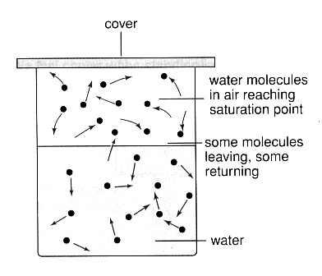

• Humans overheat in high humidity since very little sweat evaporates from
the skin.
• Evaporative air conditioners work very poorly in high humidity - the air
already contains a large amount of water.

Exposed Area

• The larger the surface area, the faster the evaporation rate.

A large surface means there is a greater volume of air into which particles can escape and
a larger number of particles can leave the liquid.

Air Movement

• The faster the air moves above the surface, the faster the evaporation rate.

Air moving across the surface takes the saturated air away from the surface. More particles can then evaporate into the "new" air until it too becomes saturated.

• Washing will dry faster on a windy day compared to a still day (if the temperatures are
the same).

• A wind blowing on the human body causes a higher evaporation rate and the person
feels cooler. This is called the wind chill factor and is commonly expressed in
countries with very cold winter conditions.

For every 1.00 kmh⁻¹, the temperature drops 1.00 °C.

VAPOUR PRESSURE AND BOILING

Boiling occurs from within the liquid and only at its boiling point.

Bubbles form within the liquid as the boiling point is approached. When the vapour pressure within these bubbles equals the atmospheric pressure outside the liquid, the liquid boils.

The boiling point depends upon:

• the type of liquid.

i.e. The strength of the bonds between particles.

• the atmospheric pressure.

Example

Water boils on top of Mount Everest at about 70 °C - too cool for effective cooking. The pressure cooker was invented to overcome this problem. It creates an internal pressure up to two atmospheres and water boils at about 120 °C - more than enough to cook food.

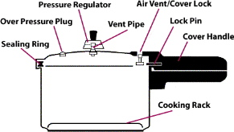

EFFECTS OF CHANGING GAS PRESSURES

Compressing gas particles together can force them to get close enough to have an attractive force occur, pulling them into a liquid state.

Once liquid, the particles have less E_{p} and this energy is given out to the surroundings as heat.

e.g. A bike pump becomes hot as the gas particles are compressed. The heat is released into the tube of the pump and your hand.

As gas is allowed to expand rapidly the opposite occurs. The particles move further apart and have more E_{p}. This energy is absorbed from the surroundings and consequently it goes cold.

e.g. Gas escaping from the large tanks at petrol stations while gas bottles are filled go very cold. Ice forms around the nozzle as water is frozen from the surrounding air.

The above thermal effects are seen in refrigerators and refrigerative air conditioning.

The liquid absorbs heat from the air and changes to a gas. The air is cooed.

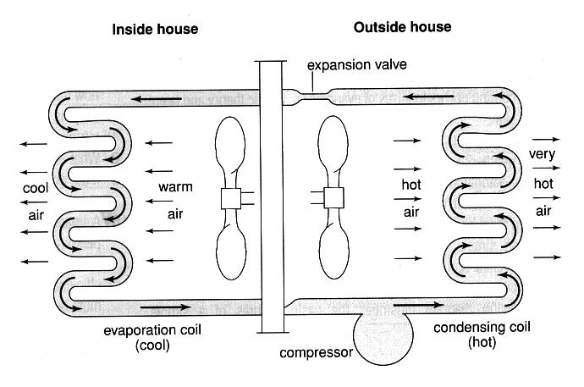
The compressor changes the gas to liquid, releasing heat in the process. This heat is removed as the liquid moves in the pipes past the fan.

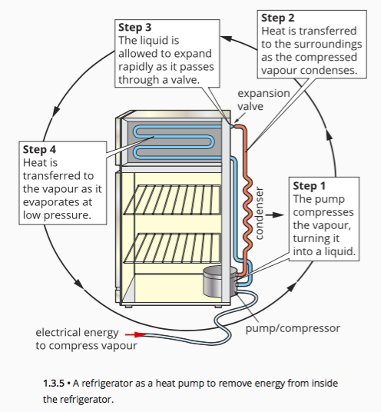

CONDUCTION

This process involves the transfer of heat energy within a material by collision between particles.

Solids are the best conductors since the particles are in fixed positions. Liquids have poor conductivity as the particles can move past each other. Gases are very poor as their particles are very far apart and move independently.

Conduction of heat occurs in two ways.

1. Energy transfer through molecular or atomic collisions.
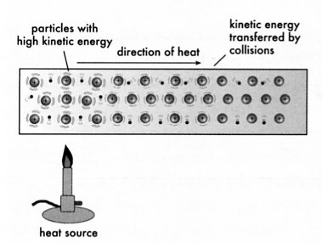
In solids, the particles vibrate in fixed positions. As one
part is heated, the particles present vibrate more rapidly
and transfer energy to neighbouring particles through the
bonds between them.

Materials that have only this type of energy
transfer are poor conductors as it is a slow process.

e.g. Plastics, glass, wood, paper, etc.

2. Energy transfer by free electrons.

Mobile or delocalised electrons gain E_{k} and consequently move quickly through the material
(they are very light compared to complete atoms). Hence the heat energy is transferred
quickly.

Materials with delocalised electrons (e.g. metals) are good thermal conductors.

Factors Affecting Thermal Conduction

The rate at which heat energy is transferred through a material depends on the following.

• Temperature difference across the material - the greater the difference the faster
the rate of energy transfer.

• Thickness of the material - a thick material requires more collisions to transfer
energy so the rate is slower.

• Surface area - a greater surface area increases the rate as more particles are
involved in the transfer process.

• Nature of the material - the greater the thermal conductivity (k), the faster the
rate.

The rate of heat transfer is given by:

** No calculations are required.

where Q = heat energy transferred (J)
t = the time taken for the heat transfer (s)
k = thermal conductivity of the material (Wm⁻¹K⁻¹)
A = area through which the heat is transferred (m²)
ΔT = the temperature difference across the material (°C, K)
L = the thickness of the material (m)
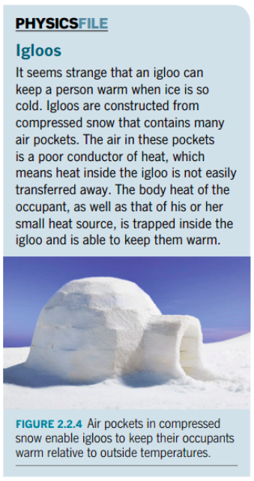
Example

A fibreglass batt used as insulation in the roof of a house has a thickness of 10.0 cm. Its dimensions are 1.80 m x 1.20 m while the temperature inside the roof is 56.0 °C on a warm day. The temperature on the ceiling side is 32.0 °C. At what rate is heat transferring through the batt onto the ceiling of the house?
(k = 0.0400 Wm⁻¹K⁻¹ for fibreglass)

Conductors And Insulators
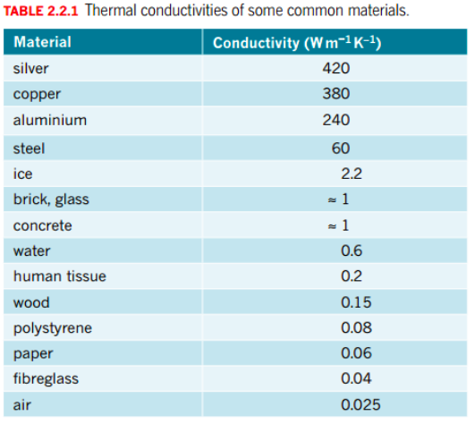
There is great variation in the thermal conductivity of different materials. Some are listed in the table right.

Metals are the best conductors of heat while non-metals are generally poor conductors and hence referred to as insulators.

Liquids and gases are particularly poor conductors of heat, although they can readily transfer heat by the action of convection currents.
CONVECTION
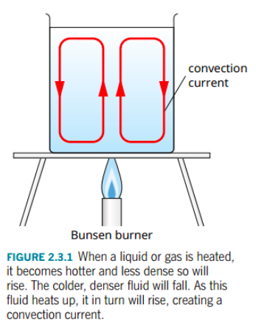
Convection transfers heat within a liquid or gas by the mass movement of particles from one part of the material to another.

Although liquids and gases are poor conductors of heat, they transfer heat rapidly by convection currents.

If the material is heated in one part, the particles there will move further apart (expansion occurs) and the material becomes less dense. It will rise and move to the top of the material where it will cool, become more dense and sink.

Thus a convection current is established.

Examples
Warm water expands, becomes less dense and rises.
Water cools and moves to the sides, becomes more dense and sinks.
Cool water moves in to replace the warm water as it rises.
1. Container of water being heated from below.

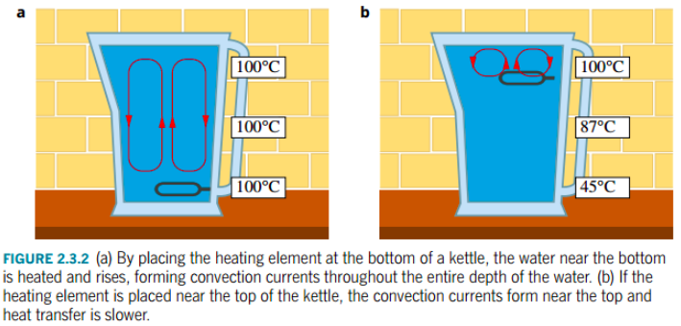
2. Land and sea breezes

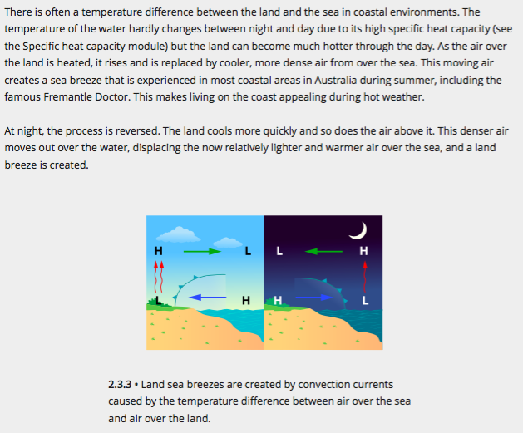

3. Solar hot water systems.

Cold water absorbs heat, becomes less dense and rises to the top of the tank attached to the solar collectors. Hot water is drawn from the top of the tank while cold water enters at the bottom.

Hot water rises up the tubes inside the collectors.
Cold water enters the collectors at the bottom.
Hot water is drawn from the top of the tank.
4. Human body.

Conduction is responsible for very little transfer of heat energy from the core to the outside.

Blood carries the heat to the sub-surface via convective currents. Once there, the heat is conducted the short distance to the surface where it is lost to the surrounding air by a mix of conduction, convection and radiation.

Clothing provides us with the necessary insulation when it is cold or windy. The air trapped within
and under our clothing is an excellent insulator since it has such low thermal conductivity.
Appropriate clothing will allow humans to comfortably withstand outside temperatures of -40°C

Clothing reduces heat loss by:

• minimising conduction of heat from the body. Clothing materials are poor conductors
and provide a thick barrier.

• minimising convection of heat from the body. This is especially important in windy
conditions which would otherwise continually remove the warm air layer near the
skin of our bodies.

• minimising radiation of heat from the body. The clothing essentially reduces the
difference in temperature between the outside layer of the clothing and the
environment. This dramatically reduces radiation losses.

Wind chill is due to convective effects. The wind blows away a thin layer of warm air near the skin, which would act as a heat insulator in still conditions. Cooler air comes in contact with the skin and heat loss increases. Each 1.00 kmh⁻¹ creates an effective decrease of 1.00 °C.

RADIATION

Radiation involves the transfer of energy by electromagnetic waves (light). Consequently no medium is necessary.

The type of light radiated is infrared (felt as heat), visible light and ultraviolet (not felt but causes skin damage).

When electromagnetic radiation falls on an object, it is partly reflected, partly transmitted and partly absorbed. It is the heat which is absorbed that causes a temperature rise in the material.

Some light reflected.
Some light passes straight through.
Some light absorbed as heat energy.
Incident light

Electromagnetic radiation is emitted by all objects above absolute zero temperature.

This enables night-vision cameras and goggles to pick up objects at night or in low-light conditions. The devices respond to the infrared heat given off by objects.

Objects at lower temperatures will give off longer wavelength (lower frequency) light.

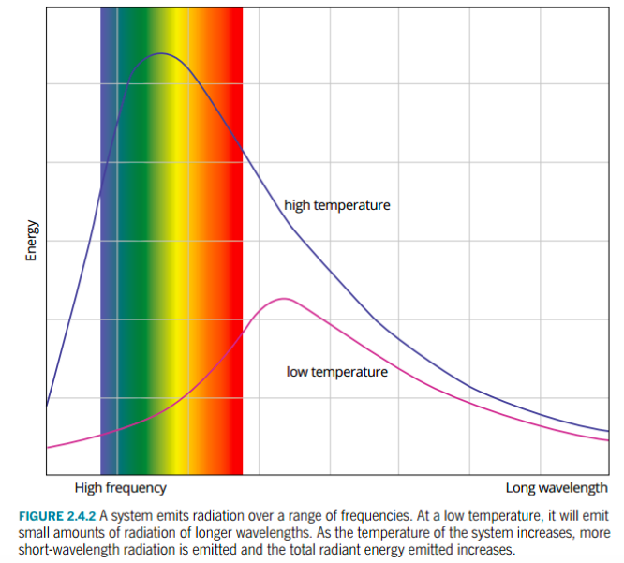
Emission And Absorption Of Radiant Energy

Flat (matt) black surfaces emit radiant energy at a greater rate than shiny, light coloured surfaces.

This means that black surfaces heat up faster and cool down faster than light coloured surfaces.

e.g. Radiators in cars and at the back of refrigerators are black to speed up the loss of heat
from the coolant inside.

Dark clothes should be worn in winter to absorb heat for warmth. Light coloured
clothing is more appropriate for summer.
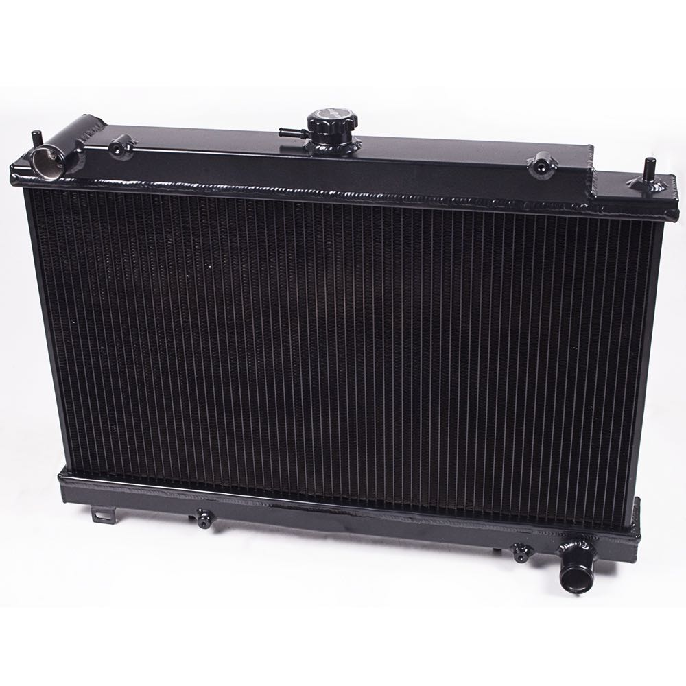
There are several factors that affect the rate of heat absorption and emission.

• Surface area - the greater the surface area, the greater the rate.

e.g. Fins are on small engines such as motor bikes and lawn mowers to release the
heat from the engine quickly.

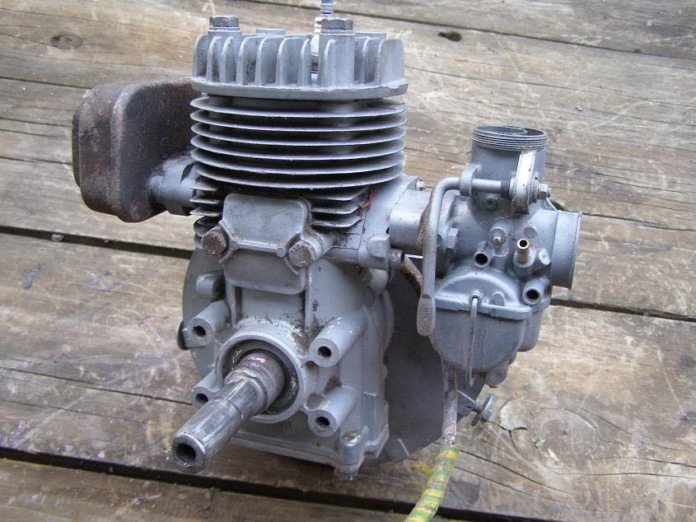

• Temperature - both the surface and the surrounding temperature of the air affects
the rate. Heat transfers between them until equilibrium is reached.

• Wavelength of the incident light - black absorbs all wavelengths but white surfaces
absorb little visible light but absorb infrared well.

• Surface colour and texture - black does best and a rough (matt) surface is best. White
shiny surfaces are poor absorbers.

THE HUMAN BODY

The body can be thought of as being made up of two parts - the core and the outer shell.

Core - contains all the vital organs and is kept at 37 °C.

Shell - is the surrounding tissue and is at a lower temperature.

In warm conditions, other body parts may be at 37 °C. In cold conditions, the vital organs receive most of the heat energy and the limbs have a reduced temperature.

Heat is lost from the body in three ways.

• Conduction

Heat is conducted through the skin if it is in contact with another material.

e.g. Feet on a cold floor - heat is conducted from the feet into the floor.

Some heat loss to the air occurs by conduction.

• Convection

Once the air around our body is heated, it becomes less dense and rises. This
convection current carries the heat from our skin away from the body.

• Radiation

The body will radiate heat in the form of infra-red light, part of the electromagnetic
spectrum.

Those parts that are warmer than others will radiate more heat energy. It is this fact
which allows infra-red thermography to be done on the body, allowing doctors to
investigate such things as the blood flow through a given area.

THE VACUUM FLASK

The vacuum flask is designed to reduce energy transfer by all three processes.

• An insulating layer of air between the inner and outer walls reduces conductive and
convective losses.

In high quality flasks, a vacuum eliminates losses from these processes entirely. No air is
present so collisions can't occur.

• The glass walls and cork/plastic stopper reduce conductive losses through the top.

• Insulating foam cushions prevent transfers between inner and outer glass flasks.

• A reflective aluminium coating on internal surfaces reduces emission of radiation from the
inner wall and contains it within the outer wall.

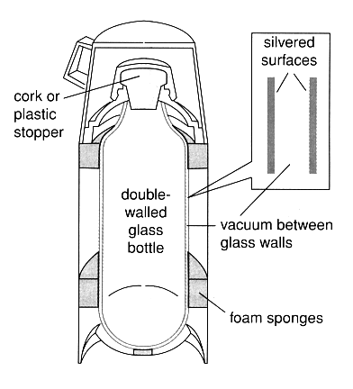

LAW OF CONSERVATION OF ENERGY

"Energy cannot be created nor destroyed but can be transformed from one type to another.
The total energy of the system is always conserved."

Heat energy usually transfers with a change in form, and this law accounts for this change.

Some forms of energy are easily transformed and are called "high grade" energy forms.
e.g. electrical, chemical.

Heat is a "low grade" since it is very difficult to transform to useful energy.

Example

Describe all the energy changes that occur as a golf ball falls onto concrete and rebounds.

At the top E_{total} =E_{p}
Ball rebounds to a smaller height.
E_{t} = E_{p}
Energy is lost to friction on the way up.
On the way down, E_{t} = E_{p} + E_{k}.

Energy is lost as heat due to friction with the air.
At impact, E_{t} = E_{k}.

Energy is lost as heat and sound.

Note

When an object is stationary at a height above a level, it has only E_{p}.
e.g. The ball at the top.

If it is moving at a height above the lowest level, it has both E_{p} and E_{k}.
e.g. The ball moving down or up.

If it is moving at the lowest level, it has E_{k} only.
e.g. The ball at impact.

The fact that energy is "lost" as heat means that not all energy has been transferred into useful energy. The production of heat shows a degradation of the energy - it is a non-useful form.

This leads to the idea of efficiency of energy transfer.

EFFICIENCY OF ENERGY TRANSFORMATIONS

The percentage of energy that is transformed usefully by a device is the efficiency of the device.

No machine is 100 % efficient - some energy is always degraded or "lost" in a non-useful form.

The efficiency is calculated as follows.

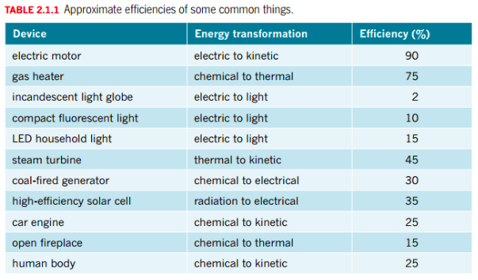

Example

A steel kettle of mass 0.800 kg holds 2.00 L of water at 25.0 °C. The electric element is able to deliver 8.10 x 10² J of heat each second. However the energy transfer is only 60.0 % efficient as a lot of heat is lost to the surrounding atmosphere. Calculate how long it takes the kettle to bring the water to the boil.
(c_{steel} = 4.40 x 10² Jkg⁻¹K⁻¹)

Need to find the energy required to change the temperature of the water.

Q_{needed} = m_{w}c_{w}Δt + m_{s}c_{s}Δt
= (2.00)(4.18 x 10³)(100.0 - 25.0) + (0.800)(4.40 x 10²)(100.0 - 25.0)
= 6.534 x 10⁵ J

COST OF ELECTRICITY

The rate at which energy is transformed from one form to another is the power that has been developed.

The power generated is given by:

where P = the power (Watts - W)
E = the energy transformed (J)
t = the time taken to transfer the energy (s)

Electrical energy is transformed into heat energy within heating devices such as radiators, kettles, air conditioners, etc.

The unit used to describe the amount of electrical energy used in the home is the kilowatt-hour (kWh).

1.00 unit = 1.00 kwh = 3.60 x 10⁶ J

There are two ways to calculate the cost of electricity used in an appliance.

1. Calculate the total energy used and divide by 3.60 x 10⁶ J. This gives the number of
units used and simple arithmetic gives the cost.

2. Convert the power rating to kW and the time of use to hours. Multiplying these
together gives kWh - the number of units used. Then do the simple arithmetic to
calculate the cost.

Example

A bar radiator is rated at 2.40 kW and is used to heat a room. It is on for 4.00 hours. If the cost per unit is 13.2 cents, calculate the cost of the electricity.

Method 1
Method 2

